FLOATING POINT MULTIPLIER



PREPARED BY : RAHUL KUMAR SEVAKULA (5464)

PROJECT DURATION: 30 DAYS
DATE OF SUBMISSION: 10TH APRIL 2008

DEPARTMENT OF ECE,
NIT WARANGAL,
WARANGAL, ANDHRA PRADESH, INDIA

Acknowledgements
I wish to thank Mr. Sarangam Sir for inspiring me to take up this project which increased the field of knowledge in Floating Point operations that are involved in Floating Point ALUs of Microprocessors and on how to develop that logic.

Abstract

For general applications a simple 32 Fixed Point may be sufficient, but computations like those in scientific computations, DSP related computations, both size and accuracy are required. A 32 bit Fixed Point multiplier can at the maximum, multiply 2³²-1 with 2³²-1 to give a 64 bit answer of 1.84467 * 10¹⁹. Around 15 years back, Fixed Point computations were sufficient. But now, large computations have become common, to the extent that Floating Point ALU is present in all processors(used in PCs and lLaptops). Here an attempt has been made to develop 32 bit Floating Point Multiplier following IEEE 754 format, fulfilling the most of the required conditions.

Aim :
To study Floating Multiplier and develop a VHDL code for the same.

Theory :
Floating Point Numbers –
The floating-point representation is one way to represent real numbers. A floating-point number n is represented with an exponent e and a mantissa m, so that:
n = b^{e} × m, …where b is the base number (also called radix)
So for example, if we choose the number n=17 and the base b=10, the floating-point representation of 17 would be:
17 = 10¹ x 1.7
Another way to represent real numbers is to use fixed-point number representation. A fixed-point number with 4 digits after the decimal point could be used to represent numbers such as: 1.0001, 12.1019, 34.0000, etc. Both representations are used depending on the situation. For the implementation on hardware, the base-2 exponents are used, since digital systems work with binary numbers.
Using base-2 arithmetic brings problems with it, so for example fractional powers of 10 like 0.1 or 0.01 cannot exactly be represented with the floating-point format, while with fixed-point format, the decimal point can be thought away (provided the value is within the range) giving an exact representation. Fixed-point arithmetic, which is faster than floating-point arithmetic, can then be used. This is one of the reasons why fixed-point representations are used for financial and commercial applications.
The floating-point format can represent a wide range of scale without losing precision, while the fixed-point format has a fixed window of representation. So for example in a 32-bit floating-point representation, numbers from 3.4 x 10³⁸ to 1.4 x 10⁻⁴⁵ can be represented with ease, which is one of the reasons why floating-point representation is the most common solution.
Floating-point representations also include special values like infinity, Not-a-Number (e.g. result of square root of a negative number).

Standard 754 for Binary Floating-Point Arithmetic Formats –
The IEEE (Institute of Electrical and Electronics Engineers) has produced a Standard to define floating-point representation and arithmetic. Although there are other representations, it is the most common representation used for floating point numbers.
The standard brought out by the IEEE come to be known as IEEE 754.
The standard specifies [1]:
1) Basic and extended floating-point number formats
2) Add, subtract, multiply, divide, square root, remainder, and compare operations
3) Conversions between integer and floating-point formats
4) Conversions between different floating-point formats
5) Conversions between basic format floating-point numbers and decimal strings
6) Floating-point exceptions and their handling, including non numbers (NaNs)
When it comes to their precision and width in bits, the standard defines two groups: basic- and extended format. The extended format is implementation dependent and doesn’t concern this project.
The basic format is further divided into single-precision format with 32-bits wide, and double-precision format with 64-bits wide. The three basic components are the sign, exponent, and mantissa. The storage layout for single-precision is show below:

Single precision
The most significant bit starts from the left.
The double-precision doesn’t concern this project and therefore will not be discussed further. The number represented by the single-precision format is:
value = (-1)^{s}2e × 1.f (normalized) when E > 0 else
= (-1)^{s}2⁻¹²⁶ × 0.f (denormalized)
where
f = (b₂₃⁻¹+b₂₂⁻²+ b_{i}^{n} +…+b₀⁻²³) where b_{i}^{n} =1 or 0
s = sign (0 is positive; 1 is negative)
E =biased exponent; E_{max}=255 , E_{min}=0. E=255 and E=0 are used to represent special values.
e =unbiased exponent; e = E – 127(bias)
A bias of 127 is added to the actual exponent to make negative exponents possible without using a sign bit. So for example if the value 100 is stored in the exponent placeholder, the exponent is actually -27 (100 – 127). Not the whole range of E is used to represent numbers. As you may have seen from the above formula, the leading fraction bit before the decimal point is actually implicit (not given) and can be 1 or 0 depending on the exponent and therefore saving one bit. Below is a table with the corresponding values for a given representation to help better understand what was explained above:

Sign(s) | Exponent(e) | Fraction | Value
0 | 00000000 | 00000000000000000000000 | +0  (positive zero)
1 | 00000000 | 00000000000000000000000 | -0  (negative zero)
1 | 00000000 | 10000000000000000000000 | -2⁰⁻¹²⁷x0.(2⁻¹)=  -2⁰⁻¹²⁷x 0.5
0 | 00000000 | 00000000000000000000001 | +2⁰⁻¹²⁷x0.(2⁻²³)  (smallest value)
0 | 00000001 | 01000000000000000000000 | +2¹⁻¹²⁷x1.(2⁻²)=  +2¹⁻¹²⁷x1.25
0 | 10000001 | 00000000000000000000000 | +2¹²⁹⁻¹²⁷x1.0=  4
0 | 11111111 | 00000000000000000000000 | + infinity
1 | 11111111 | 00000000000000000000000 | - infinity
0 | 11111111 | 10000000000000000000000 | Not a Number(NaN)
1 | 11111111 | 10000100010000000001100 | Not a Number(NaN)

Rounding Mode –
Since the result precision is not infinite, sometimes rounding is necessary. To increase the precision of the result and to enable round-to-nearest-even rounding mode, three bits were added internally and temporally to the actual fraction: guard, round, and sticky bit. While guard and round bits are normal storage holders, the sticky bit is turned ‘1’ when ever a ‘1’ is shifted out of range.
As an example we take a 5-bits binary number: 1.1001. If we left-shift the number four positions, the number will be 0.0001, no rounding is possible and the result will no be accurate. Now, let’s say we add the three extra bits. After left-shifting the number four positions, the number will be 0.0001 101 (remember, the last bit is ‘1’ because a ‘1’ was shifted out). If we round it back to 5-bits it will yield: 0.0010, therefore giving a more accurate result.
Round to nearest even - This is the standard default rounding. The value is rounded up or down to the nearest infinitely precise result. If the value is exactly halfway between two infinitely precise results, then it should be rounded up to the nearest infinitely precise even.Eg: 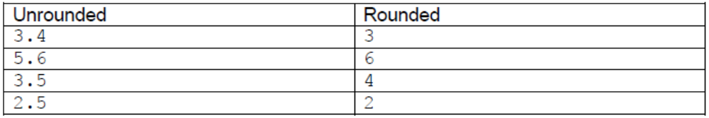

Floating Point Multiplier

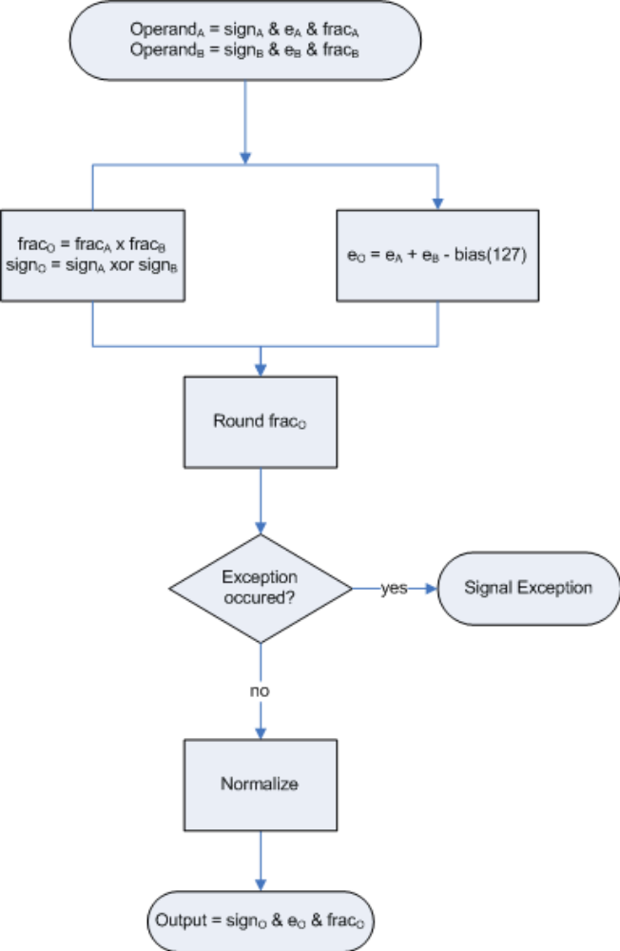

To demonstrate the basic steps, let’s say we want to multiply two 5-digits FP numbers:
2¹⁰⁰ × 1.1001
× 2¹¹⁰ × 1.0010
_________________
1.11000010

Step 1: multiply fractions and calculate the result exponent.
1.1001
× 1.0010
_________________
1.11000010
so frac= 1.11000010 and e = 2^{100+110-bias} = 2⁸³
Step 2: Round the fraction to nearest-even
frac= 1.1100
Step 3: Result
2⁸³ × 1.1100

Method of Developing:

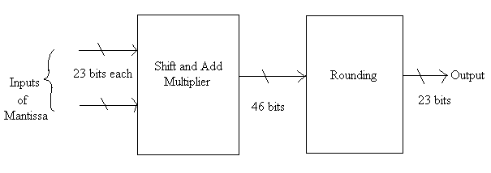

For multiplying the Mantissa, we can use Shift and Add Multiplier for unsigned multiplication and then its output is rounded.
The exponents are added and then subtracted with 127 using simple adder and subtractor.
The signs of the inputs are put to an EX-OR gate to get the final sign.

Vhdl model:

VHDL Code of Floating Point Multiplier – Main:

library ieee;
use ieee.std_logic_1164.all;
use ieee.std_logic_arith.all;

Entity FPmul is
port ( a,b : in signed(31 downto 0);
en : in std_logic;
mulout : out signed(31 downto 0));
end FPmul;

Architecture structure of FPmul is

signal roundip : signed(45 downto 0) := (others => '0');
signal enrnd : std_logic := '0';
signal exp,expadd : signed(7 downto 0) := (others => '0');
signal temp : signed(22 downto 0);

component SAMul1 is
generic (N : integer := 23; NN : integer := 46);
port (a,b : in signed(N-1 downto 0);
en : in std_logic;
c : out signed(NN-1 downto 0);
done : out std_logic);
end component;

component Round is
port(rndip : in signed(45 downto 0);
en : in std_logic;
rndop : out signed(22 downto 0);
addexp : out signed(7 downto 0));
end component;

begin

process(en)
begin
if en = '1' and en'event then
mulout(31) <= a(31) xor b(31);
exp <= a(30 downto 23) + b(30 downto 23) - 127;
end if;
end process;

s1: SAMul1 port map(a(22 downto 0),b(22 downto 0),en,roundip,enrnd);

rnd : Round port map(roundip,enrnd,temp,expadd);
mulout(22 downto 0) <= roundip(45 downto 23);
mulout(30 downto 23) <= exp + expadd;
end structure;

VHDL Code for Components:

Shift and Add Multipier with 23 bits input and 46 bits output:

library ieee;
use ieee.std_logic_1164.all;
use ieee.std_logic_arith.all;

Entity SAMul1 is
generic (N : integer := 23; NN : integer := 46);
port (a,b : in signed(N-1 downto 0);
en : in std_logic;
c : out signed(NN-1 downto 0);
done : out std_logic);
end SAMul1;

Architecture beh of SAMul1 is

begin
process(en)
variable acc,at : signed(NN-1 downto 0) := (others => '0');
variable bt : signed (N-1 downto 0) := (others => '0');
variable dt : std_logic := '0';
begin
if en = '1' and en'event then
at(N-1 downto 0) := a;
bt := b;
dt := '0';

for i in 0 to N-1 loop
if bt(0) = '1' then
acc := acc + at;
end if;
at := at(NN-2 downto 0) & "0";
bt := "0" & bt(N-1 downto 1);
end loop;
dt := '1';
end if;
c <= acc;
done <= dt;
end process;
end beh;

Rounding Operation :

library ieee;
use ieee.std_logic_1164.all;
use ieee.std_logic_arith.all;

Entity Round is
port(rndip : in signed(45 downto 0);
en : in std_logic;
rndop : out signed(22 downto 0);
addexp : out signed(7 downto 0));
end Round;

Architecture beh of Round is
begin
process(en)
variable tempop: signed(45 downto 0) := (others => '0');
variable rndopt : signed(23 downto 0) := (others => '0');
variable aexpt : signed(7 downto 0);

begin
if en = '1' and en'event then
tempop := rndip;
aexpt := (others => '0');

for count1 in 45 downto 23 loop
if rndip(count1) = '0' then
tempop := tempop(44 downto 0) & "0";
aexpt := aexpt + 1;
else
exit;
end if;
end loop;

rndopt := tempop(45 downto 22);
if rndopt(0) = '1' then
rndopt(23 downto 1) := rndopt(23 downto 1) + 1;
end if;
end if;
rndop <= rndopt(23 downto 1);
addexp <= aexpt;
end process;
end beh;

RTL ckt:

Main Floating Point Multiplier

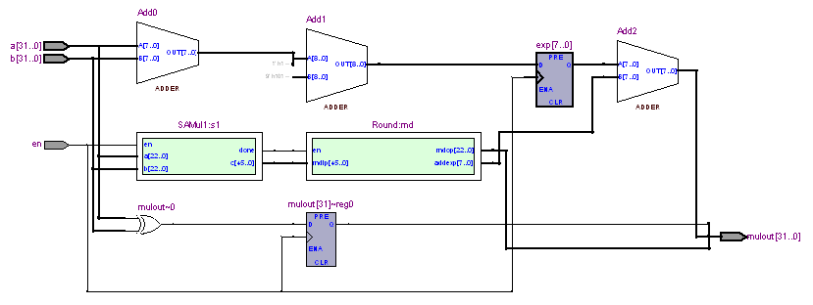

Shift and Add Multiplier:

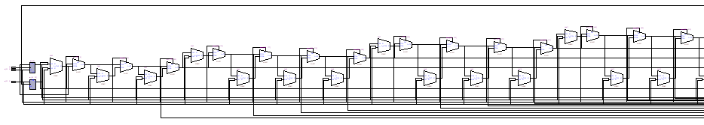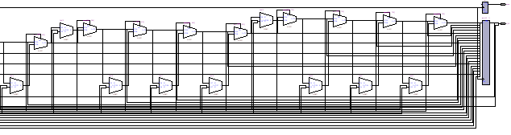

Rounding Operation:

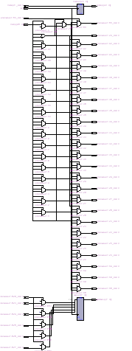

Simulation:

Main – Floating Point Multiplication:

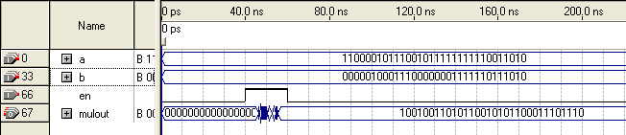

Shift and Add Multiplier:

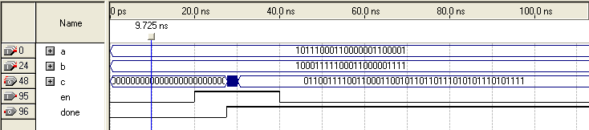

Rounding Operation:

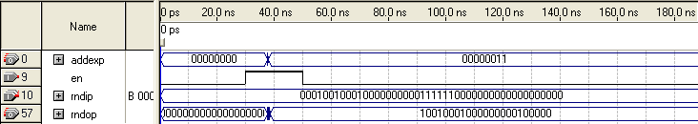

Timing Analysis:
Main – Floating Point Multiplier :

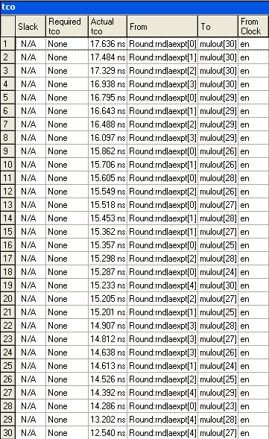
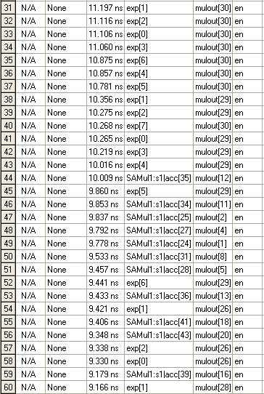
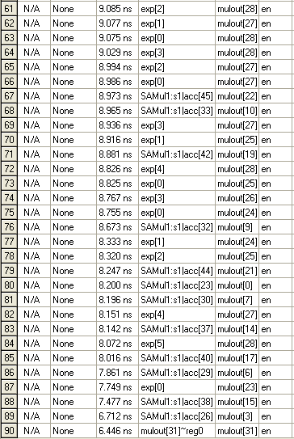

Synthesis:

For Main – Floating Point Multipier:
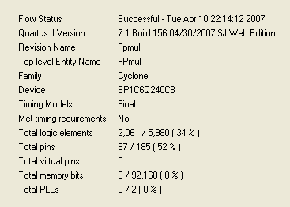

Conclusions:

Floating Point Multipier has completely understood, and also implemented using VHDL code.
Also the significance of rounding operation was understood which otherwise would not give user friendly output and also would give inaccurate results .

References:

- Floating Point Unit by Jidan Al-Eryani

